HW# 7

Luke Malloy

Problem 1:

1a. Program:

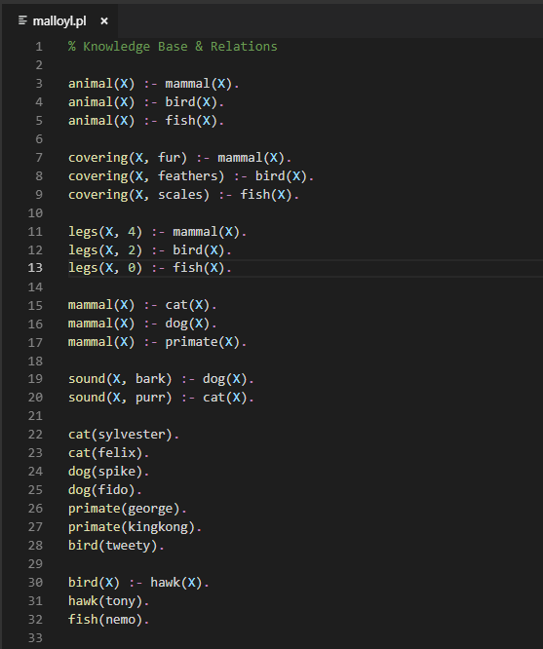

1b.

Results:

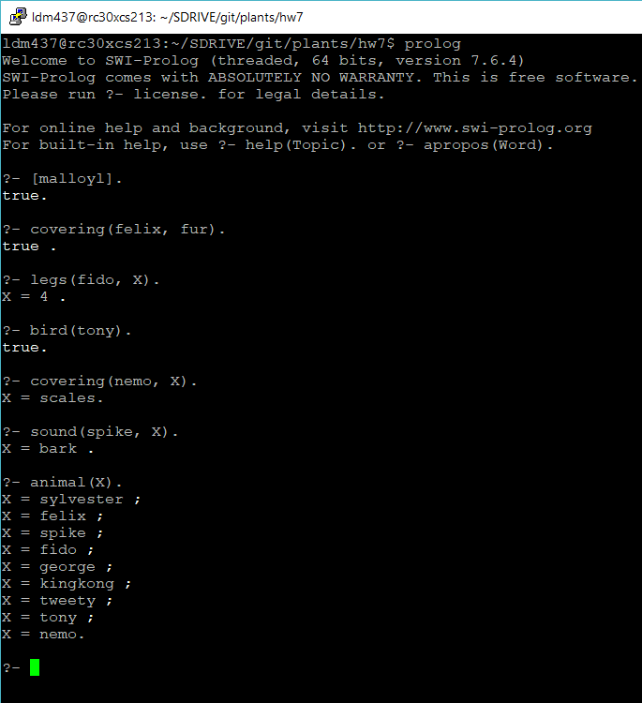

1c. Code changed to establish that all primates have 2 legs, thus george now has 2 legs.

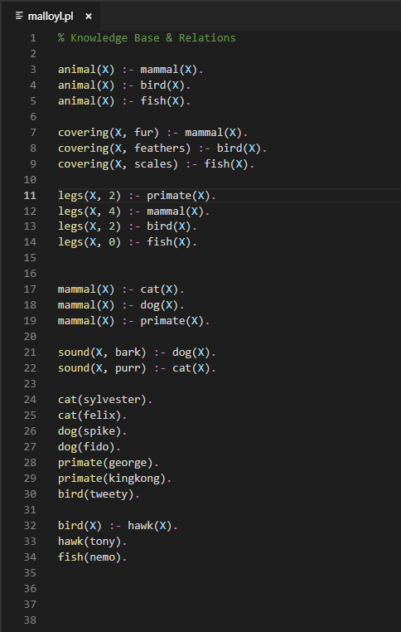

3.

Murderer is!

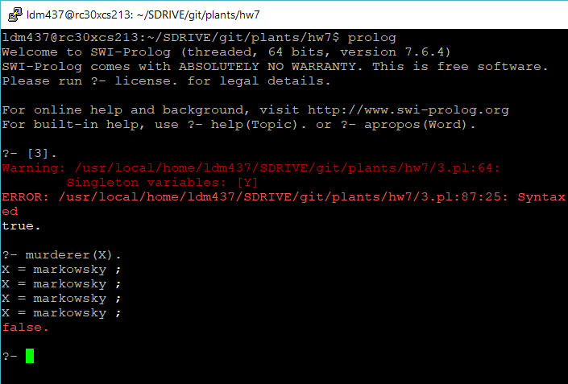

3.

Code:

access(X) :- weapon_access(X), key_access(X), crime_access(X).

weapon_access(X) :- stay(X, thursday, lab).

weapon_access(X) :- stay(X, wednesday, csOffice).

weapon_access(X) :- stay(X, thursday, bookstore).

weapon_access(X) :- stay(X, wednesday, bookstore).

key_access(X) :- stay(X, monday, csOffice).

key_access(X) :- stay(X, tuesday, lab).

key_access(davis).

crime_access(X) :- stay(X, thursday, bookstore).

crime_access(X) :- stay(X, friday, bookstore).

stay(fu, monday, csOffice).

stay(fu, tuesday, csOffice).

stay(fu, wednesday, lab).

stay(fu, thursday, csOffice).

stay(fu, friday, bookstore).

stay(mcmillin, monday, lab).

stay(mcmillin, tuesday, lab).

stay(mcmillin, wednesday, lab).

stay(mcmillin, thursday, csOffice).

stay(mcmillin, friday, bookstore).

stay(das, monday, bookstore).

stay(das, tuesday, lab).

stay(das, wednesday, bookstore).

stay(das, thursday, bookstore).

stay(das, friday, bookstore).

stay(davis, monday, bookstore).

stay(davis, tuesday, lab).

stay(davis, wednesday, lab).

stay(davis, thursday, csOffice).

stay(davis, friday, bookstore).

stay(sabharwal, monday, bookstore).

stay(sabharwal, tuesday, bookstore).

stay(sabharwal, wednesday, csOffice).

stay(sabharwal, thursday, bookstore).

stay(sabharwal, friday, bookstore).

stay(markowsky, monday, bookstore).

stay(markowsky, tuesday, lab).

stay(markowsky, wednesday, lab).

stay(markowsky, thursday, bookstore).

stay(markowsky, friday, bookstore).

stay(price, monday, csOffice).

stay(price, tuesday, csOffice).

stay(price, wednesday, lab).

stay(price, thursday, csOffice).

stay(price, friday, bookstore).

stay(tauritz, monday, bookstore).

stay(tauritz, tuesday, csOffice).

stay(tauritz, wednesday, csOffice).

stay(tauritz, thursday, csOffice).

stay(tauritz, friday, bookstore).

motive(X):-jealous(X,Y).

motive(X):-insane(X).

motive(X):-poor(X).

jealous(X,Y):- friends_with(X,Z), friends_with(Y,Z).

victim(leopold).

insane(sabharwal).

insane(tauritz).

poor(davis).

poor(fu).

poor(morales).

poor(tauritz).

friends_with(X,Y):-friends(X,Y).

friends_with(X,Y):-friends(Y,X).

friends(leopold,price).

friends(price, mcmillin).

friends(leopold, fu).

friends(fu, markowsky).

friends(markowsky, das)

friends(das, tauritz).

friends(sabharwal, tauritz).

friends(sabharwal, mcmillin).

murderer(X):- motive(X), access(X).